***Nim Nexus: Game Theory Tactics in Player-AI Encounters***

**Arya Mahesh Bhiwapurkar**  
**(221020413*)*** *Data Science and Artificial Intelligence*

*International Institute of Information Technology,*

*Naya Raipur, Chhattisgarh*  
Email ID: [arya22102@iiitnr.edu.in](mailto:arya22102@iiitnr.edu.in)

**Shubham Gupta**   
**(221020450***)  
Data Science and Artificial Intelligence*

*International Institute of Information Technology,*

*Naya Raipur, Chhattisgarh*  
Email ID: [shubham22102@iiitnr.edu.in](mailto:shubham22102@iiitnr.edu.in)

**Muskan Dewangan**   
**(221020439***)  
Data Science and Artificial Intelligence*

*International Institute of Information Technology,*

*Naya Raipur, Chhattisgarh*  
Email ID: [muskan22102@iiitnr.edu.in](mailto:muskan22102@iiitnr.edu.in)

**Subhali AR Otti**   
**(221020451***)  
Data Science and Artificial Intelligence*

*International Institute of Information Technology,*

*Naya Raipur, Chhattisgarh*  
Email ID: [subhali22102@iiitnr.edu.in](mailto:subhali22102@iiitnr.edu.in)

*Abstract*— The implementation of the Nim game in Python represents a fascinating journey into the world of computational gaming, offering a platform for strategic engagement and cognitive development. This project aims to create an interactive and educational experience where players can hone their logical reasoning and decision-making skills. By simulating the Nim game, players can explore the complexities of game theory and strategic thinking, enhancing their problem-solving abilities. The program's user-friendly interface and dynamic gameplay make it an enjoyable and intellectually stimulating experience for players of all ages.

Keywords— Nim game, Python, computational gaming, strategic engagement, cognitive development, logical reasoning, decision-making skills, game theory, strategic thinking, problem-solving abilities, user-friendly interface, dynamic gameplay, educational experience.

# INTRODUCTION

The implementation of the Nim game in Python marks an exciting foray into the realm of computational gaming, offering an engaging platform for players to delve into strategic thinking and logical reasoning. Nim, a classic two-player mathematical game, has captured the fascination of mathematicians, computer scientists, and enthusiasts for centuries. This project aims to recreate the Nim game in Python, providing an interactive environment where players can challenge themselves against an AI opponent.

Nim's origins date back to ancient times, with variations found in cultures around the world. Despite its simple rules, Nim presents intriguing mathematical properties and strategic challenges, making it an ideal candidate for implementation in a programming project. By simulating the Nim game, this project seeks to offer players an immersive experience that not only entertains but also educates, fostering the development of critical thinking skills and algorithmic problem-solving abilities.

# BACKGROUND

The Nim game, with its origins shrouded in antiquity, has long been regarded as a fascinating example of strategic gameplay rooted in mathematical principles. Believed to have originated in China or ancient Egypt, Nim has evolved over the centuries into various forms, each retaining the core concept of strategic stone removal from heaps. The game gained prominence in the mathematical community in the early 20th century, thanks to the work of mathematicians such as Charles Bouton, who analyzed its mathematical properties.

Nim's simplicity belies its strategic depth, making it a popular choice for teaching fundamental concepts of game theory and mathematical reasoning. The game's strategic elements, combined with its mathematical underpinnings, make it an intriguing subject for computational implementation. By simulating the Nim game in Python, this project aims to explore the intersection of mathematics, logic, and programming, providing a platform for players to engage with these concepts in a dynamic and interactive manner.

# PROBLEM STATEMENT

The primary objective of this project is to develop a Python program that accurately simulates the Nim game and enables interaction between a human player and an AI opponent. The program must adhere to the rules of the game, handle player inputs effectively, and provide an AI opponent capable of making strategic moves based on the current game state. The challenge lies in designing efficient algorithms for determining the AI's move and ensuring a seamless and engaging gameplay experience for the player.

The Nim game poses several computational challenges, particularly in the design of the AI opponent. The AI must be capable of evaluating the current game state, anticipating the player's moves, and selecting the optimal move to maximize its chances of winning. Additionally, the program must provide a user-friendly interface that allows players to easily interact with the game, selecting heaps and specifying the number of stones to remove.

By addressing these challenges, this project aims to create a compelling and educational gaming experience that not only entertains but also enhances players' strategic thinking and problem-solving skills. Through the implementation of the Nim game in Python, players can explore the fascinating world of mathematical games and gain a deeper appreciation for the complexities of strategic decision-making.

# METHODOLOGY

The methodology for implementing the Nim game in Python involves a systematic approach to designing, coding, and testing the game to ensure its functionality and user-friendliness. The project is divided into several key steps, each focusing on a specific aspect of the game's development.

The first step involves researching the rules and strategies of the Nim game to gain a thorough understanding of its mechanics. This research serves as the foundation for designing the game's algorithms and user interface.

Next, the game's core logic is implemented in Python, focusing on key functionalities such as initializing the game state, handling player moves, and determining the AI's moves. This step involves careful planning and coding to ensure that the game behaves as expected and provides a challenging experience for the player.

The user interface is designed to be intuitive and easy to use, allowing players to interact with the game seamlessly. This involves creating graphical elements such as buttons and text fields to display the game state and receive player input.

Finally, the game is tested extensively to identify and fix any bugs or issues. This testing phase ensures that the game is stable, functional, and provides an enjoyable experience for players.

# IMPLEMENTATION

The implementation of the Nim game in Python is achieved through a combination of data structures, control flow statements, and user interface elements. The game's core logic revolves around managing the state of the game, handling player moves, and determining the AI's moves.

The game begins by initializing a random number of stones in each heap, creating a dynamic and unpredictable gameplay environment. Players take turns removing stones from the heaps, with the goal of being the player to remove the last stone.

The AI opponent uses a simple yet effective strategy to determine its moves. It evaluates the current state of the game and selects a random valid move, aiming to deplete the heaps strategically while preventing the player from gaining a significant advantage.

Here, Fig1 shows how the code has been implemented from the player’s perspective and Fig2 shows the code implementation from the AI’s perspective.

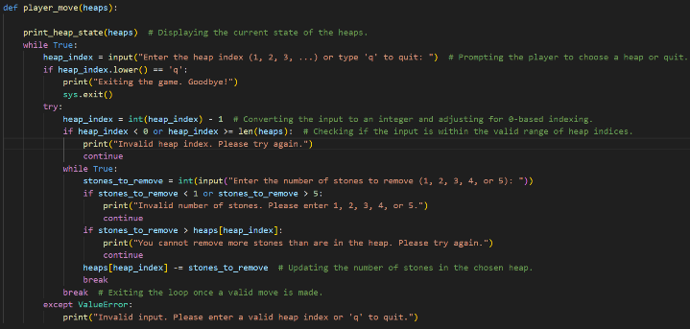

***Fig1. Player’s strategic code***

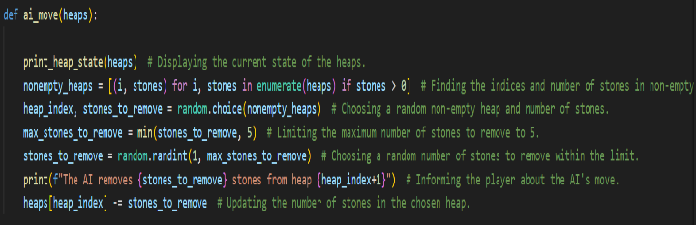

***Fig2. AI’s strategic code***

# RESULTS

The results of the implemented Nim game demonstrate its effectiveness in providing an engaging and challenging gameplay experience. Players can immerse themselves in strategic battles against the AI opponent, employing various tactics and strategies to outsmart their adversary. The program's intuitive interface and responsive gameplay mechanics contribute to a seamless and enjoyable gaming experience.

Sample outputs from the program showcase the dynamic nature of the Nim game, with players and the AI making strategic moves to gain the upper hand. Despite the AI's reliance on a random strategy, it poses a formidable challenge to players, requiring them to devise effective counter-strategies to secure victory.

Overall, the implementation of the Nim game in Python demonstrates the potential of programming to create interactive and educational gaming experiences. By simulating a classic game like Nim, this project provides a platform for players to hone their strategic thinking skills and enjoy a challenging gameplay experience.

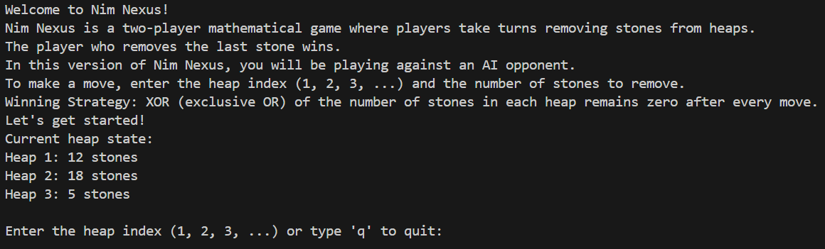

***Fig3. Starting interface***

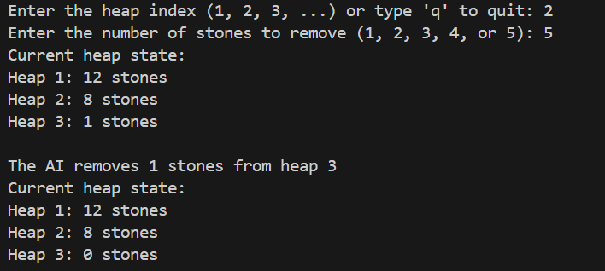

***Fig4. AI and Player getting their turn one by one***

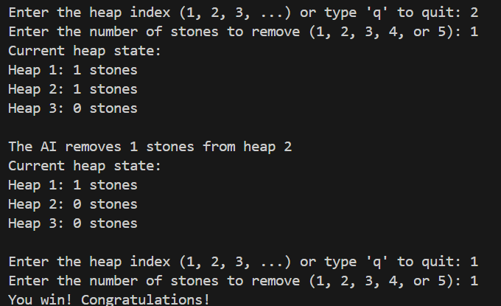

***Fig5. Player won the game***

# DISCUSSION

The discussion surrounding the implementation of the Nim game in Python highlights both the strengths and limitations of the project, along with potential areas for future improvement. The project successfully achieved its objective of providing an interactive and challenging gaming experience, allowing players to engage in strategic battles against an AI opponent. The game's implementation showcased the power of Python in simulating complex game logic and providing a seamless user experience.

One of the project's strengths lies in its simplicity and accessibility, making it easy for players of all skill levels to enjoy. The intuitive user interface and responsive gameplay mechanics contribute to a satisfying gaming experience, encouraging players to continue playing and improving their skills.

However, the AI opponent's strategy, which is based on random moves, can sometimes lead to predictable gameplay. Future iterations of the game could explore more sophisticated AI algorithms, such as minimax or reinforcement learning, to create a more challenging and dynamic opponent. Additionally, features such as customizable difficulty levels, alternative game modes, and multiplayer support could further enhance the game's appeal and longevity.

# CONCLUSION

In conclusion, the implementation of the Nim game in Python represents a successful exploration of computational gaming and strategic thinking. The project achieved its objectives of creating an interactive platform for players to engage in strategic battles against an AI opponent, while also serving as a valuable tool for practicing logical reasoning and decision-making skills. The game's intuitive interface, responsive gameplay, and educational value make it a valuable resource for enthusiasts looking to enhance their strategic thinking skills.

While the current implementation of the Nim

game in Python provides an enjoyable gaming

experience, there is ample room for future enhancements and refinements. By exploring more advanced AI algorithms and incorporating additional features, the game can be further improved to provide a more challenging and dynamic gameplay experience. Overall, the implementation of the Nim game in Python demonstrates the potential of programming to create engaging and educational games that entertain and educate players of all ages.

*REFERENCES*

*[1] Berlekamp, E. R., Conway, J. H., & Guy, R. K. (1982). Winning Ways for Your Mathematical Plays, Volume 2. Academic Press.*

*[2] Russell, S. J., & Norvig, P. (2016). Artificial Intelligence: A Modern Approach (3rd ed.). Pearson Education.*